Plot 1: Failed attempts by Emirate size

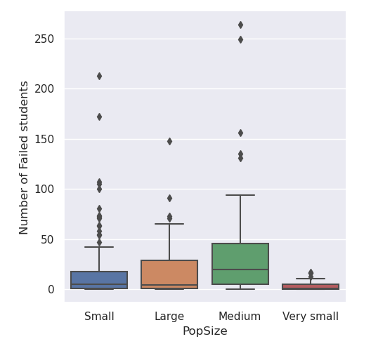

Plot 2: Pass attempts by Emirate size

